**Name :Yadwinder Singh**

**UID : 23BCS10091**

**Class: 622-B**

**Frontend CI + Deploy (S3 + optional CloudFront)**

name: Frontend CI & Deploy to S3

on:

push:

branches: [ "main" ]

jobs:

build:

runs-on: ubuntu-latest

steps:

- uses: actions/checkout@v4

- uses: actions/setup-node@v4

with:

node-version: 18

- name: Install & Build React App

run: |

cd frontend

npm ci

npm run build

- name: Deploy to S3

uses: aws-actions/s3-sync@v2

with:

source: ./frontend/build

destination: s3://${{ secrets.S3_BUCKET }}

args: --delete

env:

AWS_ACCESS_KEY_ID: ${{ secrets.AWS_ACCESS_KEY_ID }}

AWS_SECRET_ACCESS_KEY: ${{ secrets.AWS_SECRET_ACCESS_KEY }}

AWS_REGION: us-east-1

- name: Invalidate CloudFront Cache (optional)

if: ${{ secrets.CLOUDFRONT_DISTRIBUTION_ID != '' }}

uses: chetan/invalidate-cloudfront-action@v2

with:

distribution: ${{ secrets.CLOUDFRONT_DISTRIBUTION_ID }}

paths: "/*"

aws-region: us-east-1

env:

AWS_ACCESS_KEY_ID: ${{ secrets.AWS_ACCESS_KEY_ID }}

AWS_SECRET_ACCESS_KEY: ${{ secrets.AWS_SECRET_ACCESS_KEY }}

**Backend CI + Deploy (EC2)**

name: Backend CI & Deploy to EC2

on:

push:

branches: [ "main" ]

jobs:

test:

runs-on: ubuntu-latest

steps:

- name: Checkout repo

uses: actions/checkout@v4

- name: Setup Node.js

uses: actions/setup-node@v4

with:

node-version: 18

- name: Install dependencies

run: |

cd backend

npm ci

- name: Run tests

run: |

cd backend

npm test

deploy:

runs-on: ubuntu-latest

needs: test

if: success()

steps:

- name: Checkout code

uses: actions/checkout@v4

- name: Deploy to EC2 via SSH

uses: appleboy/ssh-action@v1.2.0

with:

host: ${{ secrets.EC2_HOST }}

username: ubuntu

key: ${{ secrets.EC2_SSH_KEY }}

script: |

cd /home/ubuntu/app/backend

git pull origin main

npm ci

pm2 restart all

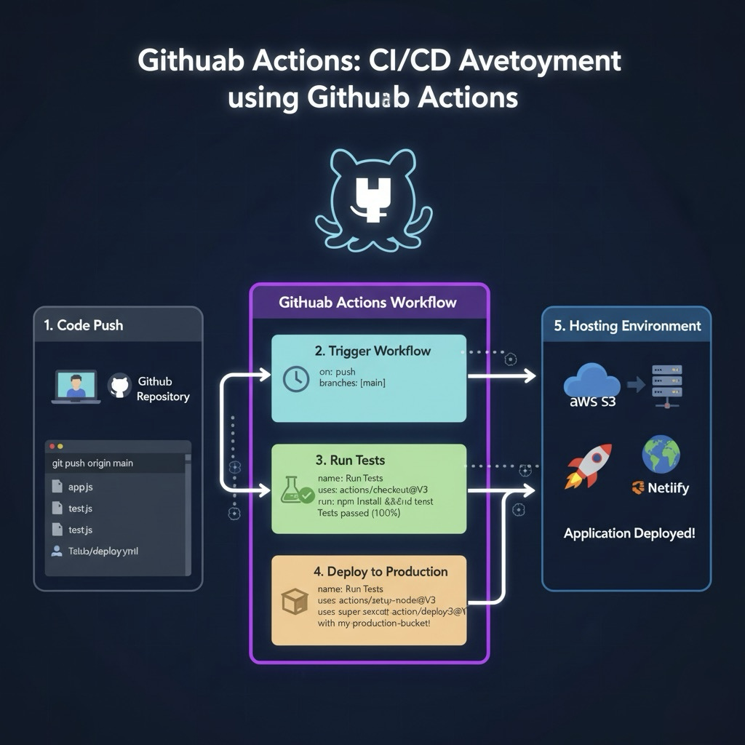

**Output in image form :**